**JavaScript Interview questions:**

1. What are the different Data types in JavaScript?

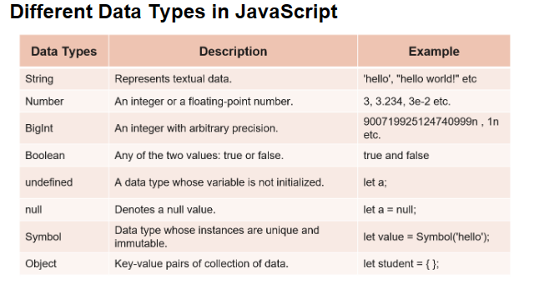

1. What is the output of :

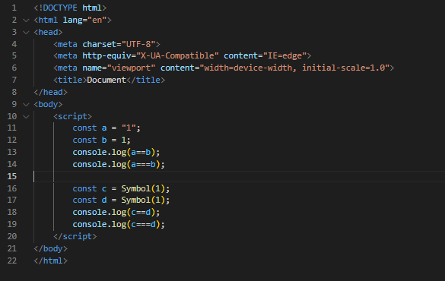

Output:

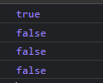

1. Which function is used to identify the type of the variable?

Ans: typeof(variableName)

1. Is JavaScript dynamically typed language or Statically typed language?

A: Dynamically typed language.

1. What is the difference between statically typed and dynamically typed language?

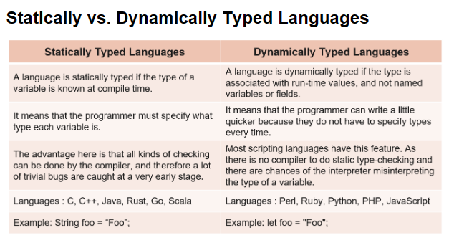

4. How do you initialize an object in JavaScript?

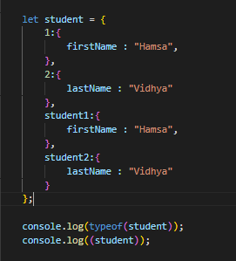

Output:

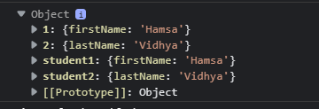

1. What are the conditional statements in JS?

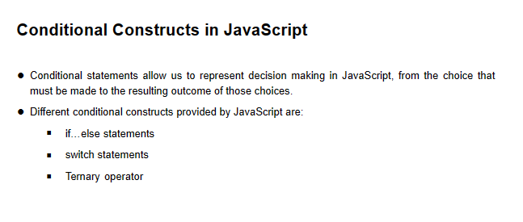

1. Loops in JS?

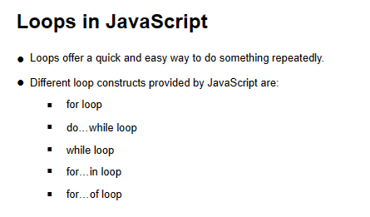

1. What are the different variations of for loop?

Ans: Normal for,

for…in loop,

for….of loop?

1. What is the difference between for..in and for…of loop?

For….in 🡪 fetch the index.

For…of 🡪 fetch the values.

1. What is the output of:

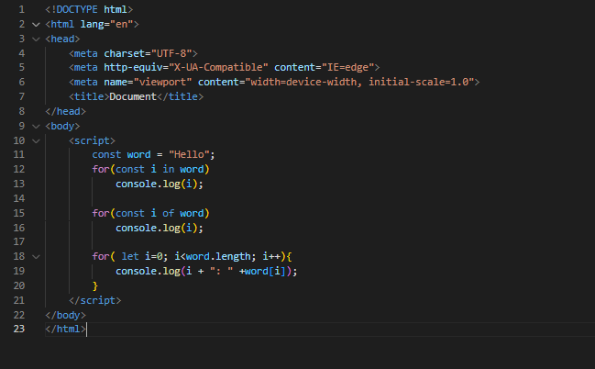

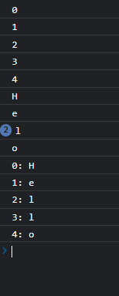

1. Write a program to convert only the vowels present in a word to uppercase.

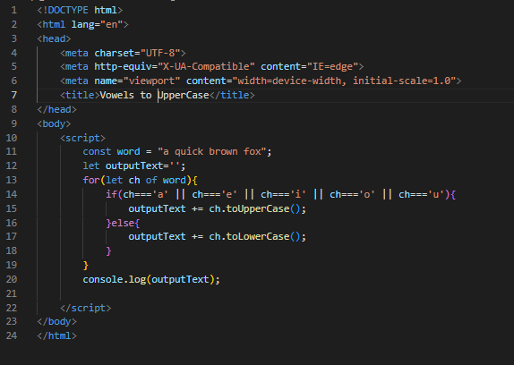

Output:

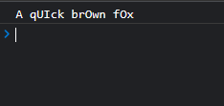

1. Find the output:

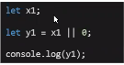

Output: y1 will be 0 as x1 is undefined.

OR operator takes the right value if the left value is undefined, null or false.

1. Find the output:

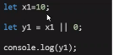

Output: y1 is 10 as x1 value is present;

OR operator takes the right value if the left value is undefined, null or false.

1. Fine the output:

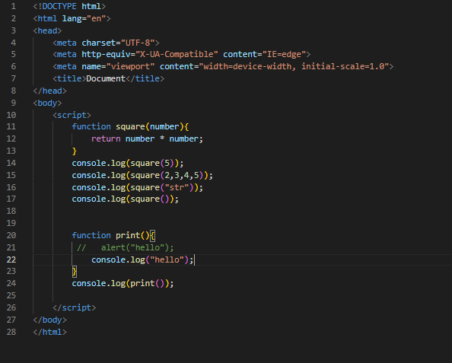

1. Convert the following traditional function to arrow function:

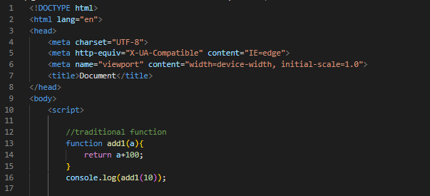

Ans:

